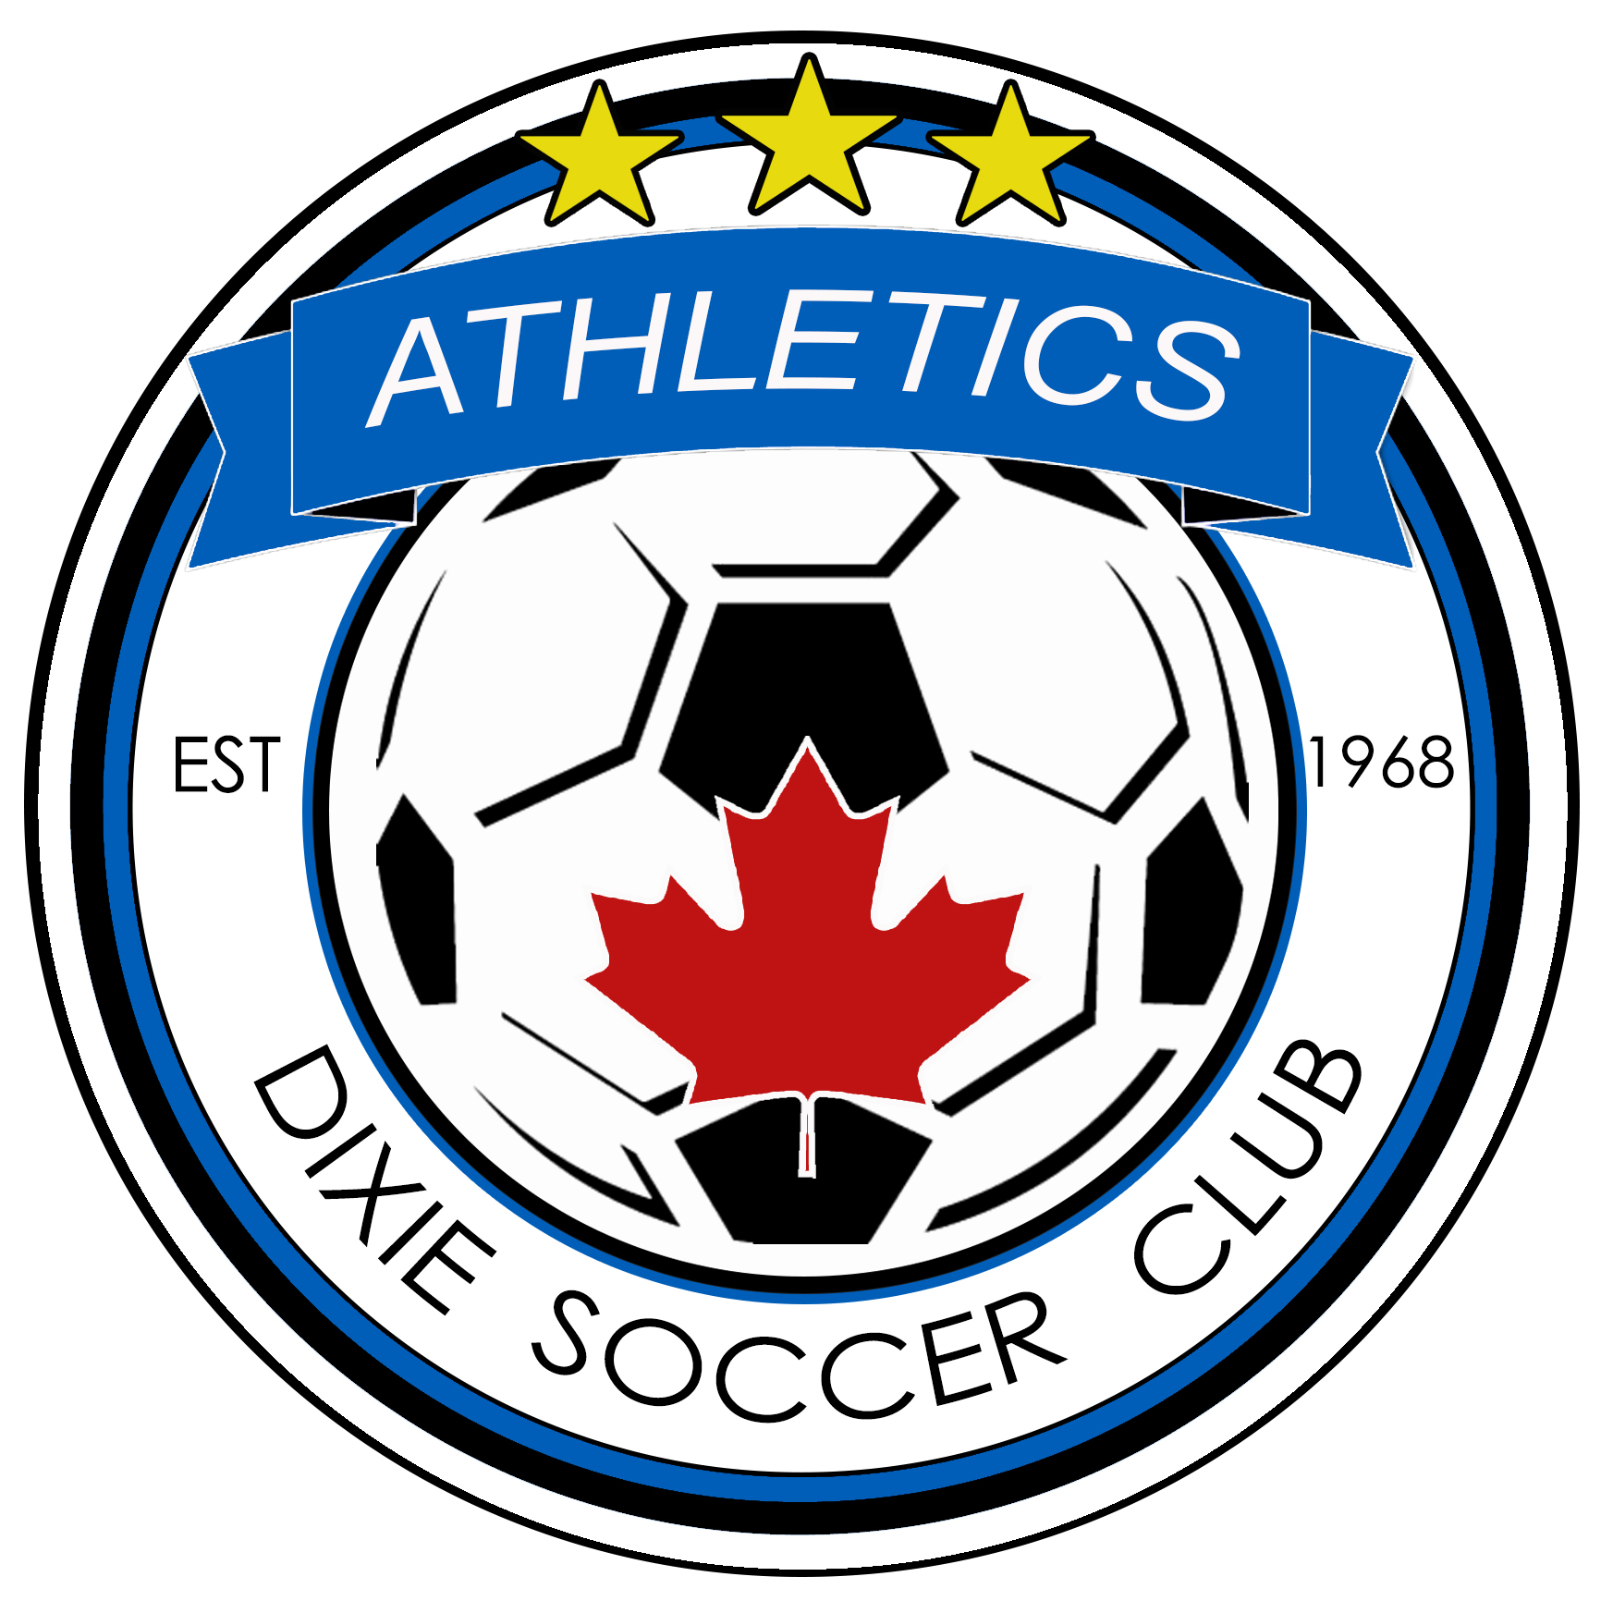
DIXIE SOCCER CLUB
Home of the Athletics
www.dixiesoccerclub.com

TEAM OFFICIAL APPLICATION FORM

Development Division (U8/U12) REP Division (U13 and above)

Position: Head Coach Assistant Coach Manager

Division: Girls Age Group: _____________ Boys Age Group: ______________

Season: Indoor Outdoor

Applicant Information (APPLICANT MUST BE 18 YEARS OF AGE OR OLDER TO APPLY)

Name: _______________________________________________________________________________

Address: ______________________________________________________ Apt/Unit: ______________

City: _____________________________________________ Postal Code: _______________________

Telephone: Home: ______________________________ Cell: __________________________________

Email: _______________________________________________ OS#: __________________________

Head OR Assistant Coach Name: ___________________________________________________________

Previous Coaching Experience
# of years coaching soccer. Please provide details of most recent teams coached:
NAME OF ORGANIZATION YEAR AGE GROUP GENDER LEAGUE
1.
2.
3.

Coach/Manager Qualifications
Certification Level (please list all completed coaching certifications, practical and theoretical).
1.
2.
3.
4.

2019/2020 COACHES CODE OF CONDUCT

- I understand that my role as a Coach is to employ the very best of my efforts and abilities to develop the skills of the players and the cohesiveness of the team and to make all my players’ soccer experience as enjoyable and rewarding as possible in a safe environment.

- I will teach my players to play by the rules, and to resolve conflicts without resorting to hostility.

- I will be a positive role model for my players and will not engage in any kind of unsportsmanlike conduct with any official, referee, coach, player, parent or spectator such as booing and taunting or using profane language or gestures. I will encourage good sportsmanship amongst my players by showing respect and courtesy, and by demonstrating positive support for all participants at every game. I will not smoke, consume alcohol or drugs or engage in abusive language at games or within sight of any of the players.

- I will respect the Referee and his/her authority during games and will never criticize, contradict or interfere with Referees or other Coaches at the game field. I will take the time to speak with them privately if I have any concerns or complaints, and if necessary, I will report any serious and irreconcilable issues or discipline or harassment to the REP Director and/or PHSA.

- I will never be alone and out of sight with a player other than my own child (and thus will also never transport a child other than my own child, alone to a Club activity, but may do so if at least my own child is present as well).

- I will be in Club coaching attire always at games and practices.

- I will ensure that only those players who are registered with Dixie S.C. for the current season will play or practice with the team.

- I will respect and adhere to the Rules and Regulations of the Ontario Soccer Association as well as the rules and regulations of the Club.

- I have read and agree to the current Rules & Regulations which are posted in the REP manual. These include rules with respect to equal playing time and substitutions; the position of the coach and players on the field and sidelines; and playing rules that apply to the age group.

I also acknowledge that if I fail to abide by the Code, I may be subject to disciplinary action, to be determined by the Club as appropriate.

Agreement and Consent
I have reviewed, and I agree to abide by the Dixie Soccer Club’s “Team Official Code of Conduct” and have fully and accurately completed this application. I have also attached a valid police check (Vulnerable Sector Screening Program). All information provided will be held in confidence.

____________________________________ _____________________
Signature Date

For Club use only
Date application received: | Notes:
Police Check Form submitted: Date: __________________ Clearance received date: ____________________

